EXPERIMENT NO-15: DECISION TREE
Aim
To write a Python program to implement a Decision Tree classification algorithm using the scikit-learn library.
Algorithm
- Import the required libraries.
- Create a sample dataset containing input features and target classes.
- Split the dataset into training and testing data.
- Create a Decision Tree Classifier.
- Train the classifier using the training data.
- Predict the output for the test data.
- Display the predicted results and accuracy.
Python Program
from sklearn.tree import DecisionTreeClassifier
from sklearn.model_selection import train_test_split
from sklearn.metrics import accuracy_score

# Dataset
X = [
[1, 1],
[1, 0],
[0, 1],
[0, 0],
[1, 1],
[0, 0]
]

# Target values
y = [1, 1, 0, 0, 1, 0]

# Split dataset
X_train, X_test, y_train, y_test = train_test_split(
X, y, test_size=0.3, random_state=42
)

# Create Decision Tree
model = DecisionTreeClassifier()

# Train the model
model.fit(X_train, y_train)

# Prediction
y_pred = model.predict(X_test)

# Display results
print("Actual values:", y_test)
print("Predicted values:", y_pred)

# Accuracy
accuracy = accuracy_score(y_test, y_pred)
print("Accuracy:", accuracy)
Result
The Decision Tree classification algorithm was successfully implemented in Python, and the model predicted the class values for the test data with good accuracy.
Sample Output:
Actual values: [0 1]
Predicted values: [0 1]
Accuracy: 1.0
OUTPUT
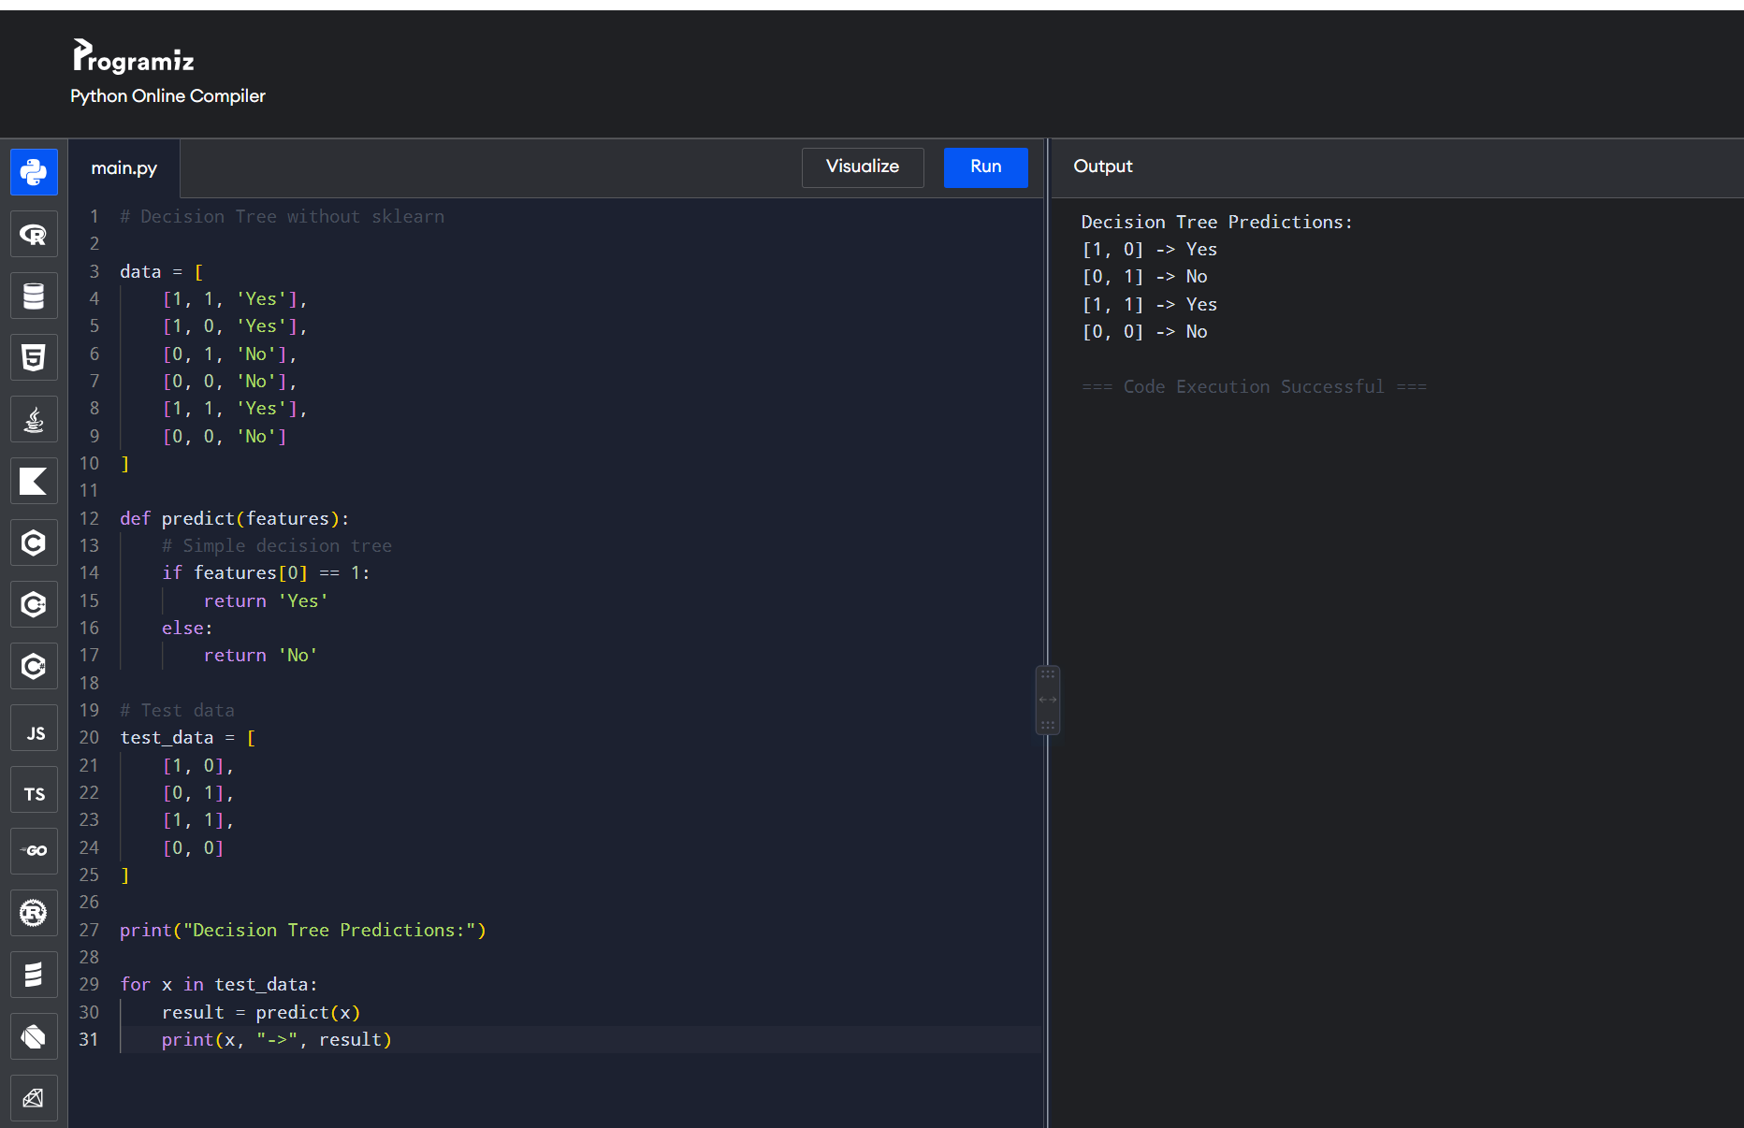

Result: Thus, the Decision Tree algorithm was successfully implemented using Python.

